**Name :**

**Roll no :**

**Group A Lab Assignment:** 5.1

**Subject :**PSDL

**Title :** Sorting of array in Ascending order

**Assignment No: 5.1**

**Title:** Embedded C Program for sorting the numbers in an array in ascending & descending order.

**Aim :** Write an Embedded C Program for sorting the numbers in an array in ascending & descending order.

**Objective:** To develop and execute embedded C program for sorting the number in an array in ascending & descending order for PIC18FXXX microcontrollers**.**

**Theory:**

**1). TRIS, PORT and LATCH registers for configuring I/O ports of PIC 18FXXX microcontrollers.**

Out of 40 pins PIC18F4550 has a total of 35 I/O (input-output) pins which are distributed among 5 Ports A,B,C,D AND E. Each Port of a **microcontroller** corresponds to three 8-bit registers (TRIS, PORT & LAT) which should be configured to use the Port for general I/O purpose.

Each of the Input/Output (I/O) available ports is provided with three registers to control their operation:

1. Port registers (PORTx) allow the user to read the logic levels on the pins. For example, reading from PORTA register returns the actual I/O pin values. Pins configured as output can also be driven by writing to PORTx.
2. Output Latch registers (LATx) can be used for both writes to the port and read-modify-write operations on the values that the I/O pins are driving. Writes to LATx are equivalent with writes to the corresponding PORTx register. Reads from LATx return register values, not I/O pin values. This prevents inadvertent modification of pins that are configured both as inputs and outputs by the software.
3. Tri-State Control registers (TRISx) allow the user to configure the direction of the pins. When a bit from register is set (logic ‘1’), the port output driver is disabled for that pin. Otherwise, if a pin is cleared (logic ‘0’) the port output driver is enabled.

To configure a particular port/pin as input, the corresponding TRIS register/TRIS bit should be set to high (1). For output, the relevant TRIS register/bit should be set to low (0).

**2). Timer Delay Implementation in PIC18F4550**

In PIC18F4550 delay is implemented with general counting loops or with timers. Looping delays have their downsides such as inaccurate delay duration and blocking precious processor time. Thus delays of the order of milliseconds are preferred to be implemented with timers. PIC18F4550 has 4 timers, each of which could be used to provide delays of a few seconds. The delay required is configured with the help of timer control registers and preload value, in accordance with the Oscillator frequency.

**Procedure:**

**Step 1:** Open MPLABX IDE on the PC for program development and create a new project and save it in a new folder.

**Step 2:** Write the program in C language for for sorting the numbers in an array in ascending & descending order.

**Step 3:** Build the program and create hex file. In case of errors correct program and rebuild to create hex file.

**Step 4:** Select Window->Target memory views->**Configuration bits** from tool bar. Select appropriate settings, generate source code and paste the configurations in the main program.

**Step 5:** Select debug project and then Finish debugger session from the tool bar.

**Step 6:** Select Window->Target memory views->**File Registers to view the output.**

**Source code :**

#include <stdio.h>

#include <stdlib.h>

#include <pic18f4550.h>

void main(void) {

inti,j,temp;

intnum_asc[]={10,2,5,1,6};

for(i=0;i<=4;i++)

{

for(j=i+1;j<=4;j++)

if(num_asc[i]>num_asc[j])

{

temp=num_asc[i];

num_asc[i]=num_asc[j];

num_asc[j]=temp;

}

}

}

**OUTPUT:**

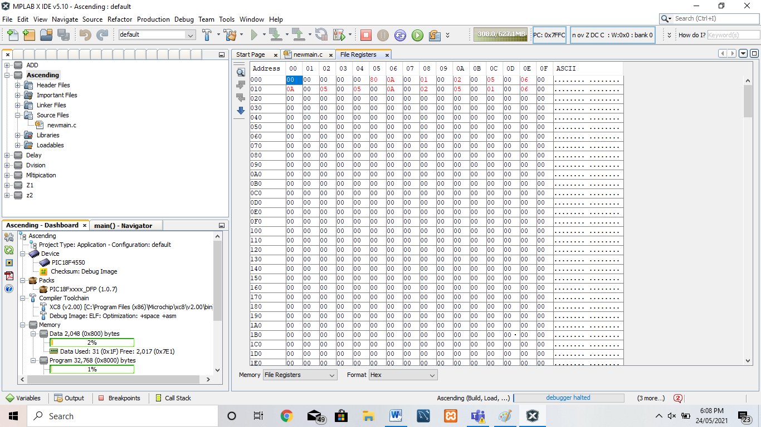

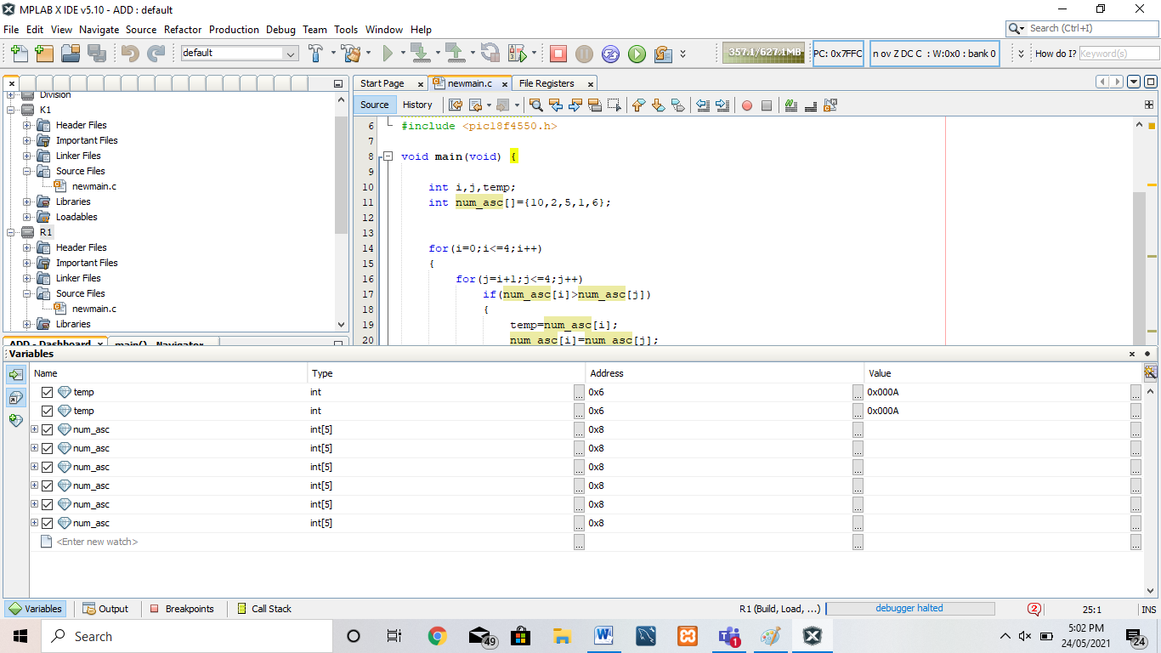

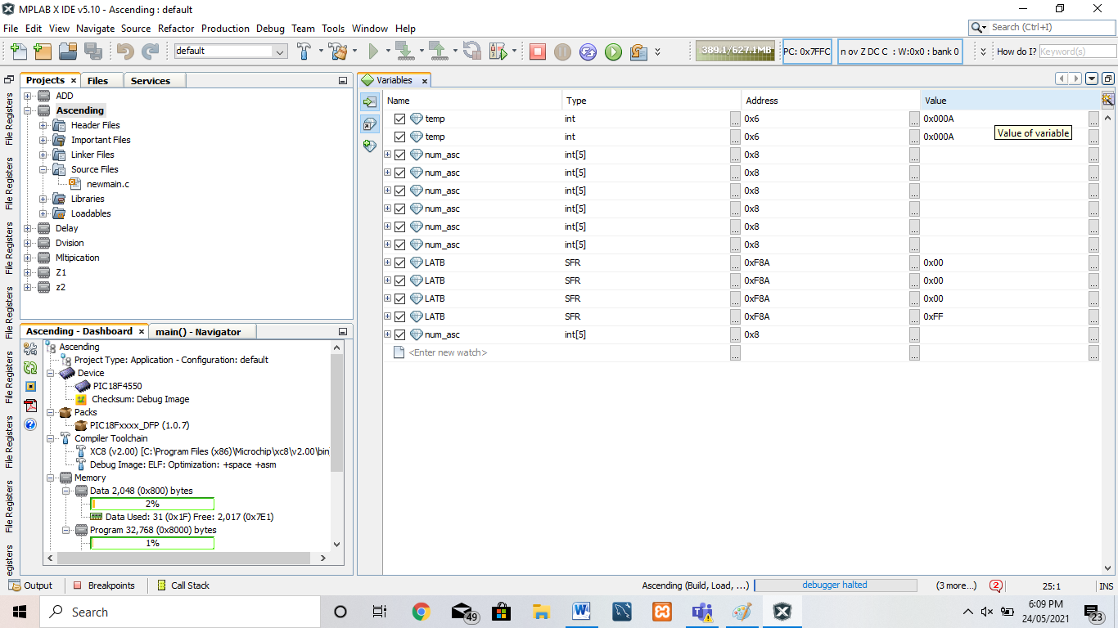

**Conclusion:** Thus, we have studied Embedded C Program for sorting the numbers in an array in ascending & descending order.